Ex.No.4: OFDMA Resource Block Allocation Date
AIM: To simulate and analyze OFDMA (Orthogonal Frequency Division Multiple Access) resource block allocation and evaluate system performance in terms of resource utilization and user throughput using MATLAB.
Procedure
1. Define the system bandwidth and calculate the number of available resource blocks (RBs) based on RB size (e.g., 180 kHz per RB).
2. Identify the number of active users in the OFDMA system for resource sharing. 3. Allocate resource blocks to each user based on a predefined or equal distribution strategy.
4. Compute Resource Block Utilization (%) using the ratio of allocated RBs to total RBs. 5. Assign modulation efficiency values (e.g., QPSK, 16-QAM, 64-QAM) for each user. 6. Calculate User Throughput (Mbps) using allocated RBs and modulation efficiency. 7. Plot graphs for RB allocation and utilization/throughput analysis using MATLAB. 8. Analyze results to evaluate spectrum efficiency and system performance.
Objective 1 Matlab Code and Output:
clc;
clear;
close all;
bandwidth = 10e6;
rb_size = 180e3;
total_RB = floor(bandwidth / rb_size);
users = 1:6;
base = floor(total_RB / length(users));
alloc = base * ones(1,length(users));
alloc(1:mod(total_RB,length(users))) = alloc(1:mod(total_RB,length(users))) + 1; utilization = (alloc / total_RB) * 100;
disp('Total Resource Blocks:')
disp(total_RB)
disp('RB Allocation per User:')
disp(alloc)
figure
subplot(2,1,1)
stem(users, alloc, 'filled', 'LineWidth', 2)
title('OFDMA Resource Block Allocation per User')
xlabel('User Index')
ylabel('Number of Resource Blocks')
grid on
subplot(2,1,2)
plot(users, utilization, '-o', 'LineWidth', 2)
title('OFDMA Resource Block Utilization (%)')
xlabel('User Index')
ylabel('Utilization (%)')
grid on
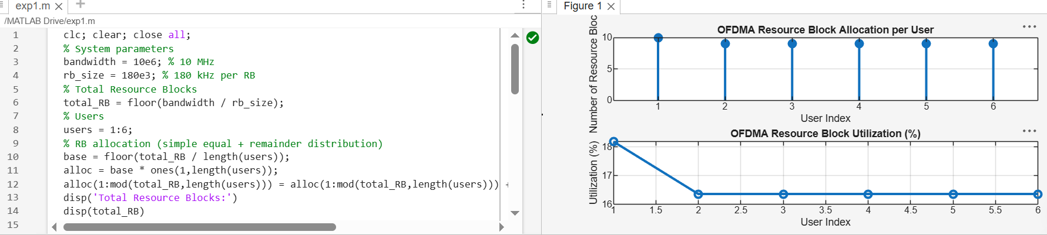
Objective 2 Matlab Code and Output:
clc;
clear;
close all;
total_RB = 50;
users = 1:5;
alloc = [12 10 9 8 11];
util = (alloc / total_RB) * 100;
disp('Resource Block Utilization (%) per User:')
disp(util')
figure

subplot(2,1,1)
plot(users, alloc, '-o', 'LineWidth', 2)
title('OFDMA Resource Block Allocation per User')
xlabel('User Index')
ylabel('Number of Resource Blocks')
grid on
subplot(2,1,2)
plot(users, util, '-s', 'LineWidth', 2)
title('OFDMA Resource Block Utilization (%)')
xlabel('User Index')
ylabel('Utilization (%)')
grid on

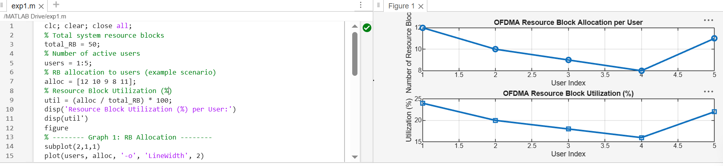
Objective 3 Matlab Code and Output:
clc;
clear;
close all;
rb_bw = 180e3;
users = 1:5;
alloc_RB = [12 10 9 8 11];
mod_eff = [2 4 6 4 2];
throughput = (alloc_RB .* rb_bw .* mod_eff) / 1e6;
disp('User Throughput (Mbps):')
disp(throughput')
figure
subplot(2,1,1)
plot(users, throughput, '-o', 'LineWidth', 2)
title('OFDMA User Throughput')
xlabel('User Index')
ylabel('Throughput (Mbps)')
grid on
subplot(2,1,2)
plot(alloc_RB, throughput, '-s', 'LineWidth', 2)
title('Resource Blocks vs Throughput Relationship')
xlabel('Allocated Resource Blocks')
ylabel('Throughput (Mbps)')
gridon 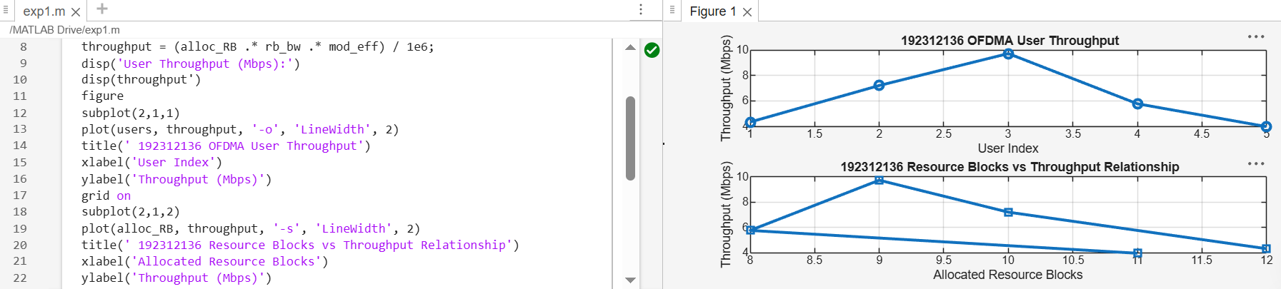
Result:
1. The Resource Block (RB) allocation was successfully simulated for multiple users in the OFDMA system, demonstrating how available spectrum is distributed among active users.
2. The Resource Block Utilization (%) analysis showed efficient usage of system resources, indicating how effectively the available RBs are assigned to users.
3. The User Throughput (Mbps) was successfully calculated based on RB allocation and modulation efficiency, showing that higher allocated RBs and higher modulation schemes result in increased throughput.

